**PEMROGAMAN WEB**



**Oleh :**

**Thoyyib Abdillah**

**Nim : 17051204058**

**Kelas : TI 2017 B**

**TEKNIK INFORMATIKA**

**FAKULTAS TEKNIK**

**UNIVESITAS NEGERI SURABAYA**

**2019**

**PEMROGAMAN WEB**

Final Project

Soal di HackerRank

1. Penyelesain Masalah :

1. Source Code :

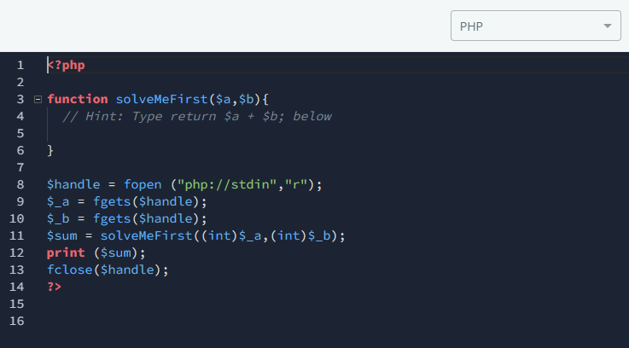Solve Me First :

# Mini-Max Sum :

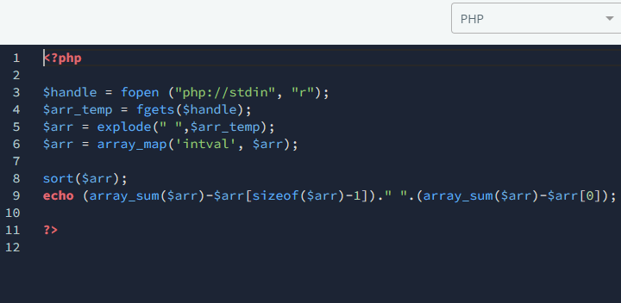

# Time Conversion :

# Grading Students :

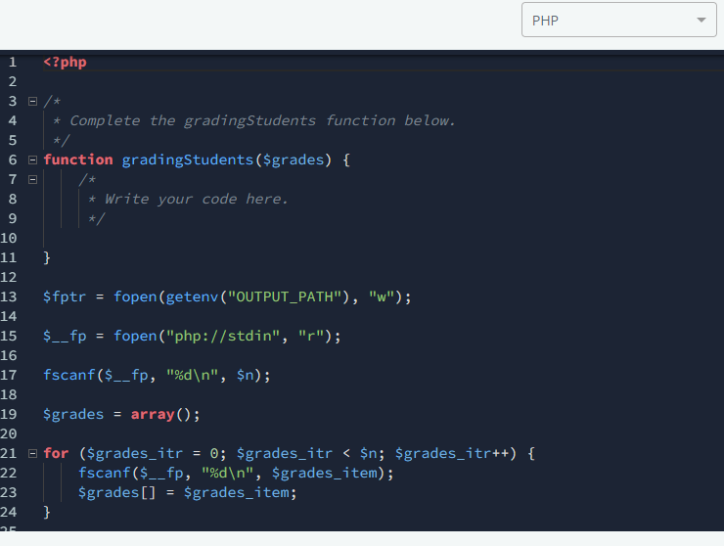

# Apple and Orange :

# Kangaroo :

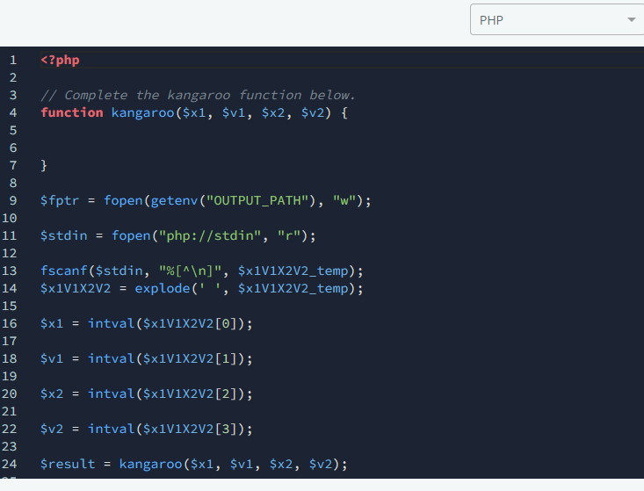

# Between Two Sets :

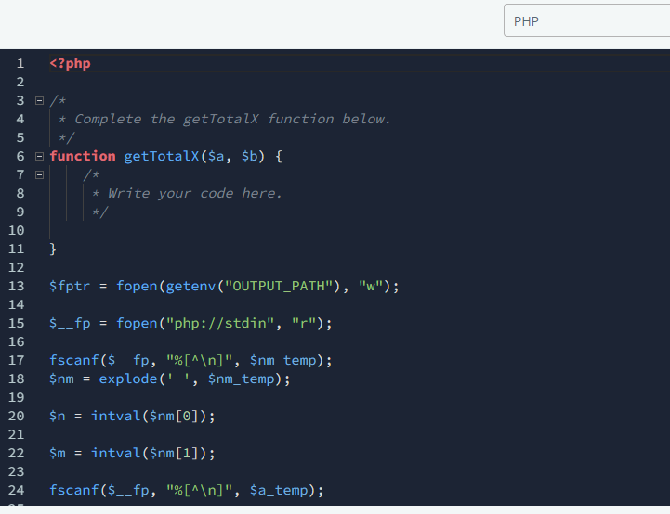

# Divisible Sum Pairs :

# Bon Appétit :

# Drawing Book :

# The Hurdle Race :

# Designer PDF Viewer :

# 

# Jumping on the Clouds :

# Minimum Distances :

# 

# Absolute Permutation :

# Intro to Tutorial Challenges :

# CamelCase :

# Ice Cream Parlor :

# Marc's Cakewalk :

# Flipping bits :

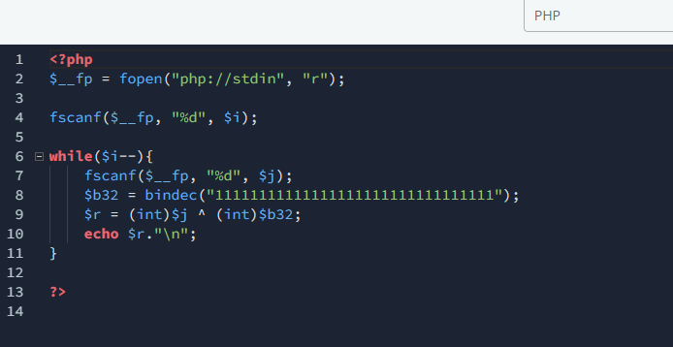

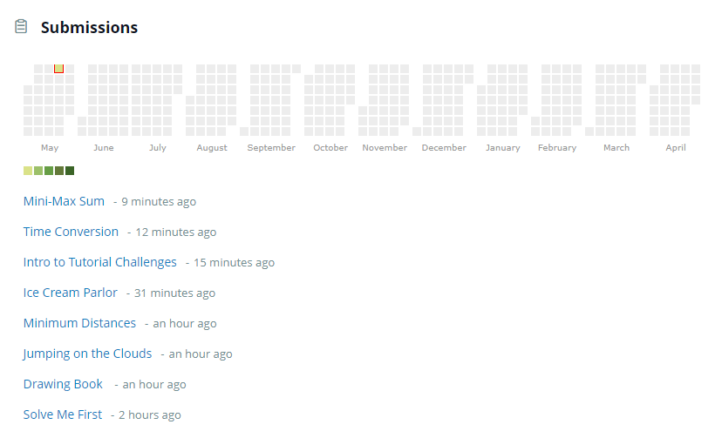History Submissions :

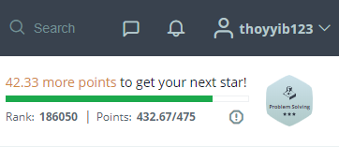Score Hackkerank :